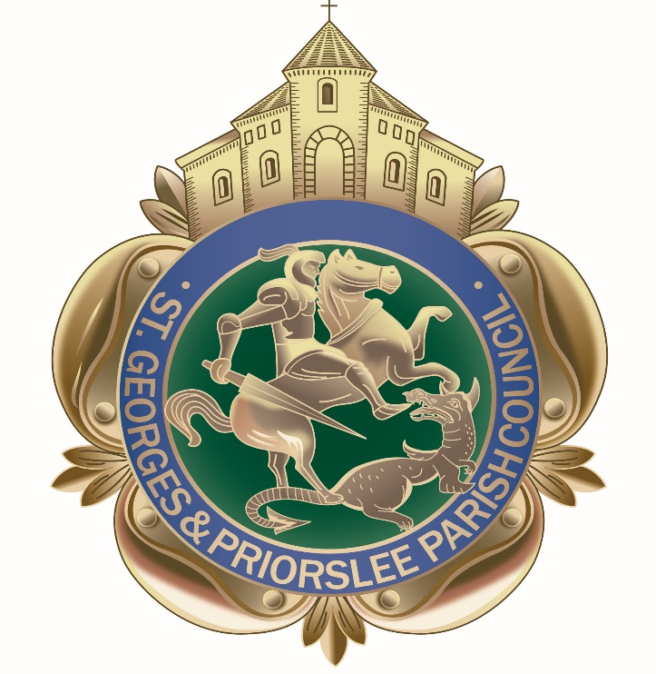

Notification of cancellation of St Georges & Priorslee Parish Council meeting due to be held Tuesday 17th March 2020

Please note the parish council meeting due to be held on Tuesday 17th March 2020, will not be going ahead due to the likelihood that the meeting would not be quorate, a majority of Councillors are unable to attend because of their age or underlying health issues which would make them more susceptible to a severe form of Coronavirus.

The next parish meeting will be held on Tuesday 21st April 2020, 7pm at the parish centre. Please note this date will be subject to national/local circumstances prevailing at the time.
Mrs W Tonge
Parish Clerk

