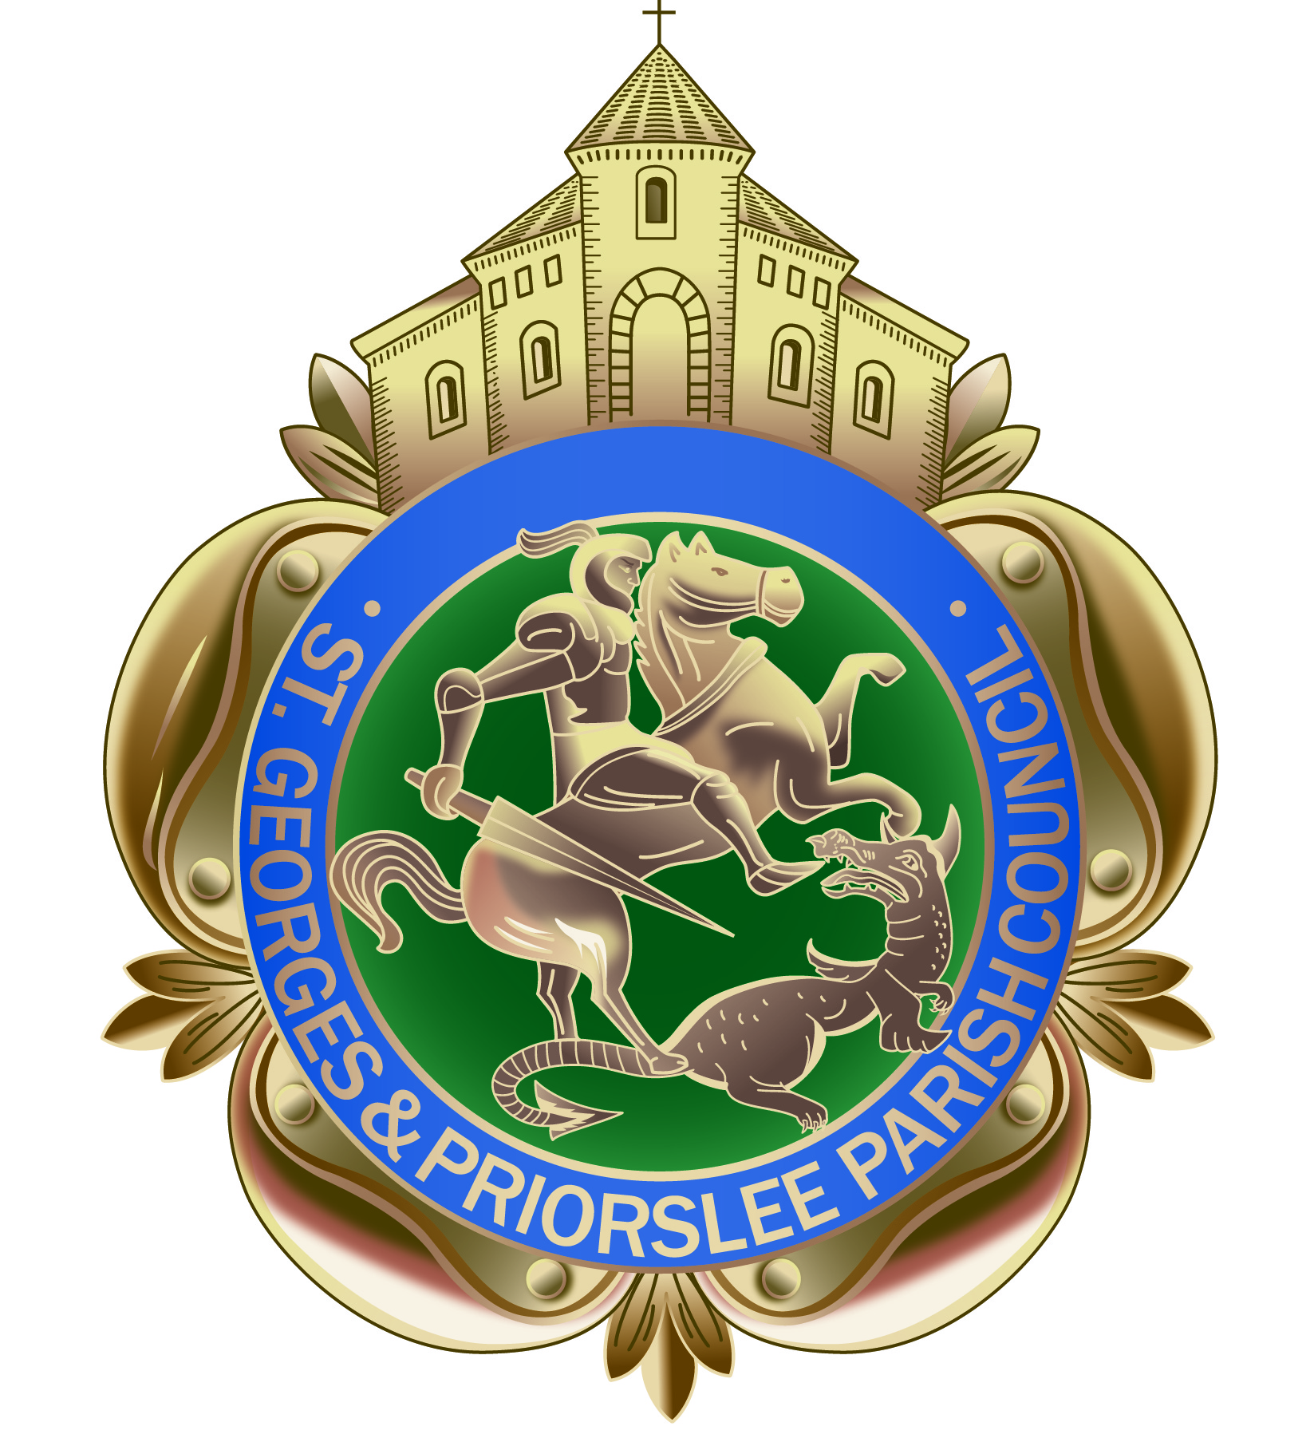

St Georges & Priorslee Parish Council
Parish Centre, Grove Street
St Georges, Telford TF2 9LJ
Tel; 01952 567700

Email: clerk@stgeorgesandpriorslee-pc.gov.uk
Website: stgeorgesandpriorslee-pc.gov.uk

TO ALL MEMBERS OF ST GEORGE’S & PRIORSLEE PARISH COUNCIL

YOU ARE HEREBY SUMMONED TO ATTEND THE PARISH MEETING OF St Georges & Priorslee Parish Council, to be held on Tuesday 18th June 2019 at 7.00pm at St Georges & Priorslee Parish Centre, Grove Street, St Georges.

Yours faithfully

Wendy Tonge (Mrs)
Parish Clerk

A G E N D A

- Public question time. Fifteen minutes is allowed for any questions from the public.

- Apologies: To accept the apologies of those unable to attend.

- Declarations of Interest:
    - Personal
    - Prejudicial
- Minutes: to approve the minutes of the meeting held on 21st May 2019 (copy provided).

- Clerks update on any matters arising from the previous meeting.

6. Planning:
- To consider any Planning Applications (Schedule attached)
- Planning Decisions - Planning decisions received and ‘Full Granted’ from Telford & Wrekin
(Schedule attached)
7. Finance:
(a) To approve accounts due for payment in June 2019 (Schedule provided)

8. Internal Audit May 2019 visit & report: To agree if any response is required to internal auditor.

9. Annual return/year end accounts
(a) To approve Annual Return Governance Statement 2018/2019: to be signed by Chairman
(b) To approve accounting statement 2018/2019 and accompanying year end accounts: to be signed
by Chairman
- Clerk to inform council of intention to display notice of Electors Rights
10. Community Projects & Events: Officers briefing to Members.

11. Freestone Avenue Play Area: to consider quotes for installation of fencing to neighbouring properties.

12. Grant applications: to consider Grant support applications (Schedule provided).

13. Parish Plan Committee Meeting: to agree a date for future meeting.

14. Chain of office: to consider renewal of Vice-Chairman’s chain of office

15. Correspondence received:
(a) Invitation to Wellington TC Mayor’s Civic Event on 30th June.
(b) SALC – Code of Conduct Training for Councillors on 18th July 2-4pm at Dawley House.

