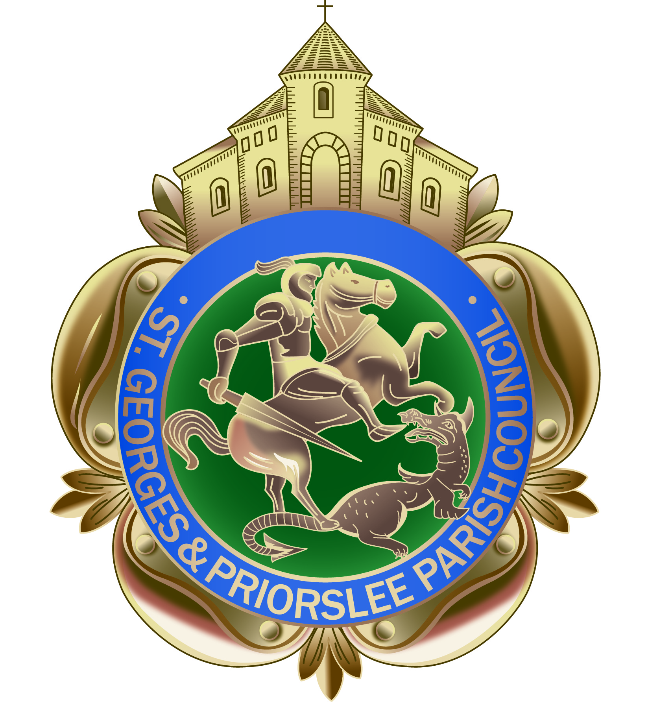

**St Georges & Priorslee Annual Meeting**

**Tuesday 16th April 2019 at**

**St Georges & Priorslee Parish Centre**

**Present:Councillor** R Overton (Chairman)

**Councillors:** Mrs J Overton, S Overton, Mrs B Richards, R Williams, J Minor, S Ali, I Fletcher, T Hoof

In attendance: W Tonge (Parish Clerk), A Atkinson(Community events & projects Officer**)**

**1. Chairman’s welcome**

The Chairman welcomed all those present and opened the meeting**.**

**2. Guest speaker**

The Chairman welcomed Steven Shaw Chairman and volunteer of Walking for Health, Telford & Wrekin. Steven delivered a detailed overview and played a short video of the walking initiative. The scheme encourages people to participate in a number of local walks which is supervised by volunteers who complete training to become a walk leader. The walks are free, fun and friendly and provide a perfect opportunity to get active and meet new people. The Chairman thanked Steven for giving his time to attend the meeting and providing the Parish Council with such useful information.

**3.Annual report of the work of the Parish Council by Chairman, Cllr Richard Overton – presented by the Parish Clerk, Powerpoint presentation presented by A Atkinson**

A warm welcome to you all at this Annual Parish Meeting of St Georges & Priorslee Parish Council.

**Introduction**

Firstly, I would like to start by thanking my fellow colleagues for the commitment in serving the parish council for the past 4 years. In an ever changing environment and financially challenging times, we have continued to support and deliver services with the community whilst remaining the voice on local issue and concerns.

At the beginning of each year the council sets outs it main priorities and key objectives, below is an overview of progress made during the past 12 months.

**Parish Centre**

The parish centre continues to be well used by local groups and training providers, staff ensure the building is well maintained. Improvements this year include, new signage, both outside the school gates and above the entrance, providing clearer instructions on how to access to the building.

**Community Directory**

The directory has been well received by local residents and groups, we will continue to update it on and annual basis.

**Grant Allocation**

The parish council continue to allocate grants to voluntary groups, charitable and other organisations carrying out community activities. This year we allocated £4,000 of funding to 10 groups/charities.

**Support to local groups**

Support has been provided to local groups in a variety of ways, a few examples include:

* Purchase and installation of a bench and supply of spring bulbs to Priorslee Residents to enhance the Community Area near Teece Drive.
* Support to St Georges Partnership at their local events – Christmas Crafts, St Georges Day.
* Support to St Georges Community Group in holding a half-term craft activity.

**Projects and Events**

The parish council have continued to work with the community and support and deliver a programme of annual events and community activities, aimed to bring residents and families together, this year the following events and activities were held:

* Parish Summer Fayre at Priorslee Village Green
* Senior Citizens Day trip to Llandudno
* Community litter-picks
* McMillan Coffee Morning
* Craft stall at the Christmas lights switch on event
* Senior Citizens Christmas shopping trip to Chester
* ‘Tell us your views’ - Community Coffee morning
* Remembrance Sunday/Silent Soldier Silhouettes
* ‘Breaducation’ awareness day
* Parish Council’s 30th Anniversary Celebration
* Children’s craft activity

**Long-term Projects**

Longer term projects remain a priority, the parish council have and will continue to provide support and management the following:

* Replacement of the Priorslee Clock.
* Mining/Industrial Heritage memorial.

**Community Projects**

We have continued to support and deliver initiatives to ensure that satisfaction levels regarding the local remain high, this year we have been active in supporting the following initiatives:

* Painting of parish bus shelters
* Painting of the memorial gates
* Support the maintenance of the Village Green Sensory Garden
* Replaced the broken kick-rails/installation of bollards at the Flash
* Funded 10 new Grit bins at various locations
* Campaigned for improvements where speeding is an issue – Priorslee Avenue, Holyhead Road
* Installed no parking signs along the Grove Estate
* Issued 100’s of free dog-poo bags
* Weekly reporting on local environmental issues to the Borough Council
* Made recommendations on approximately 40 planning applications
* Installation of 9 new parish noticeboards
* Introduced a new and improved Christmas lighting scheme
* Provided an additional Christmas tree to the entrance of The Cloister Estate
* Continue to maintain Freeston Avenue Play Area

**Finance**

The parish council have been able to ensure a ‘zero’ increase to the Precept, and have been successful in securing approximately £11,000, of external funding from a variety of sources to help support specific projects and events.

**Staff**

This year the parish council took the decision to make the post of Community Events & Projects Officer permanent. I am sure you will agree this has provided us with great value for money and Audrey has continued to help us deliver a wide and varied number of events as well as supporting local groups and projects. I am also delighted to share that our parish clerk was successful in achieving her CiLCA qualification, she continues to manage the administration of our Council and supports Councillors and Staff. Due to changes with the PET Team we have allocated additional duties to our existing Booking Clerk, who has already been busy supporting us to ensure we continue to keep our local area clean and safe

On behalf of all of parish members and residents, I would like to thank this small team of staff for their continued hard work and commitment.

**4.Questions to Councillors**

None received.

Chairman………………………………………. Date………………………………………………