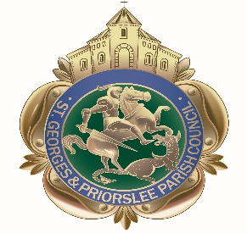

St Georges & Priorslee Parish Council
Annual Parish Meeting
7pm
Tuesday 16th April 2019
At
The Parish Centre, Grove Street, St Georges TF2 9LJ
AGENDA

- Welcome by the Chairman of the Parish Council.

- Guest Speaker: Steven Shaw, Walking for Health Project

- Presentation on the year’s work of the Parish Council.

- Parishioners opportunity to discuss local matters with
Councillors.

