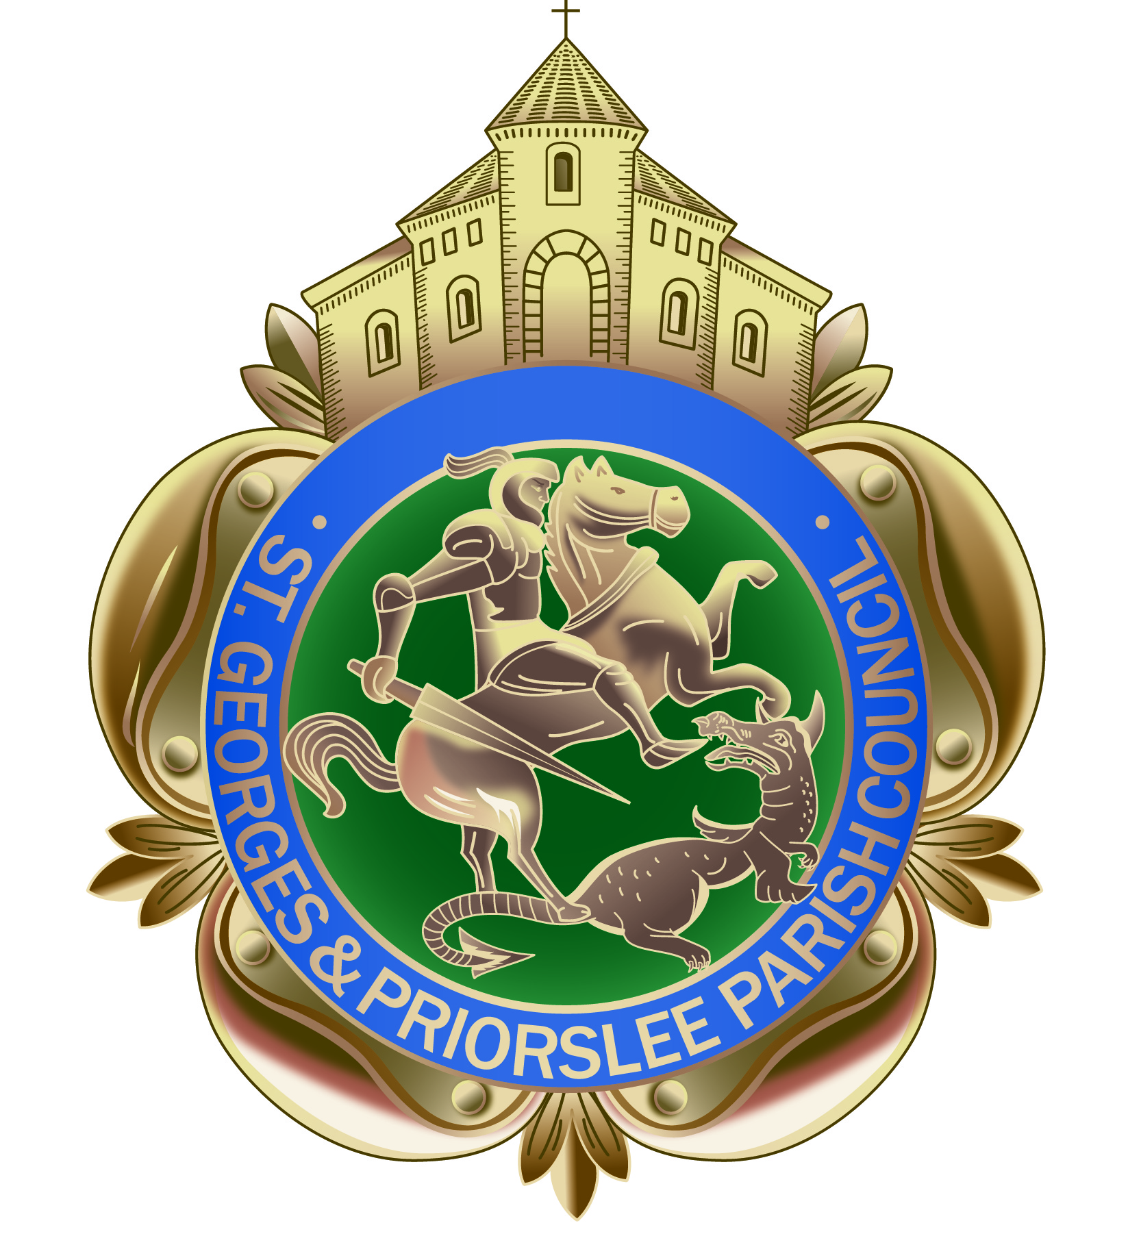

St Georges & Priorslee Parish Council
Parish Centre, Grove Street
St Georges, Telford TF2 9LJ
Tel; 01952 567700

Email: clerk@stgeorgesandpriorslee-pc.gov.uk
Website: stgeorgesandpriorslee-pc.gov.uk

TO ALL MEMBERS OF ST GEORGE’S & PRIORSLEE PARISH COUNCIL

YOU ARE HEREBY SUMMONED TO ATTEND THE PARISH MEETING OF St Georges & Priorslee Parish Council, to be held on Tuesday 18th December 2018 at 7.00pm at St Georges & Priorslee Parish Centre, Grove Street, St Georges.

Yours faithfully

Wendy Tonge (Mrs)
Parish Clerk

A G E N D A

1. Public question time: 15 minutes is allowed for members of the public to raise their concerns
2. Apologies

3. Declarations of Interest:

(a) Personal
(b) Prejudicial
4. Minutes:
(a) To approve the minutes of the parish meeting held on 20th November
2018 (copy provided)

5. Clerks update on any matters arising from the previous meeting

6. T&WC Grounds & Cleansing Services Contract: Presentation by Angie Astley, Dave Hanley and
representative from Ideverde

7. Planning:
    - To consider any Planning Applications for December 2018 (Schedule attached)
    - Planning Decisions - Planning decisions received and ‘Full Granted’ from Telford & Wrekin (Schedule attached)

8. Finance:
(a) Monthly Payment Schedule- To approve payments of accounts due in
December 2018

9. Community Projects & Events: Officers briefing to Members (verbal update)

10. Repairs to The Flash knee rail: to consider request received from T&WC

11. Priorslee bus shelter damage: to consider options received from T&WC

12. Priorslee Green, Installation of Bollards: to consider quote received from T&WC

13. Installation of Hearing Loop System to Parish Centre: To consider quote received

14. Correspondence received:
(a) Mr Lawley – closure of Lloyds Bank, Donnington
(b) Mr B Dempsey – offer of prints for the parish centre
(c) Gatcombe Way Christmas lights – thank you from Mr P Thomas on behalf of residents
(d) The Cloisters Christmas Tree– hank you from J Erickson on behalf of residents
(e) Community bulb planting scheme Teece Drive – thank you from Mr P Thomas on behalf of
volunteers

15. Delegated Powers – to confirm Delegate Powers for the Chairman and Clerk on all parish matters
and Cllr R Williams on planning matters during the time between the December and January Parish
Council meetings.

16.

